KL Bakery

Driver Manual

Login

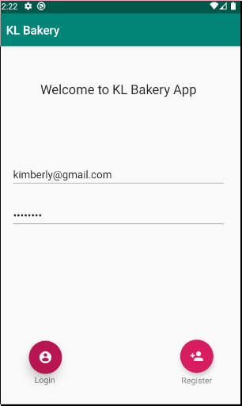

* Enter your email and password.
* Click login to login

Route Listing

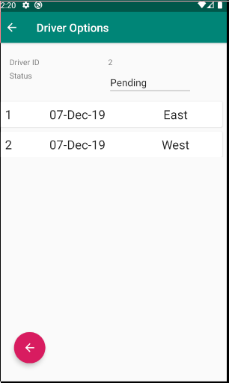

This screen shows a list of deliveries that a driver has to make in a particular day.

* Swiping a record left or right will update it to complete.
* Touching a record would open a new screen that shows all the invoices to deliver on that delivery run.
* There is a back button (large red button with the arrow) that will navigate you back onto the login screen.

Invoice List

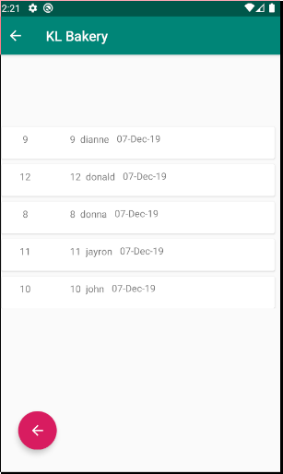

This screen shows all invoices on a particular delivery run. The first value in the list is the invoice number, the next is the order number, the third is the username of the customer and finally the last field is the date of delivery.

* Swiping left would update the status of an invoice from pending to delivered.
* To return to the delivery run listing, click the back button(large red button on the lower left of the screen).